# REPORT SUBMISSION FORM

|  |  |  |
| --- | --- | --- |
|  | |  |
| Name: | TAN WEI LIANG | |
| Partner's Name: | AINA IMANINA BINTI MOHB KHOZIKIN | |
| Group : | M5B | |
| Experiment Code: | 1TS2 | |
| Experiment Title: | THERMOELECTRIC EFFECT AND THERMAL | |
|  | CONDUCTIVITY | |
| Lecturer’s / Examiner’s Name: | Dr. Mohd Marzaini Mohd Rashid | |
| Starting Date (1st session): | 18/12/2023 | |
| Ending Date (2nd session): | 08/01/2024 | |
| Submission Date: | 20/01/2024 | |

# DECLARATION OF ORIGINALITY

|  |  |  |  |
| --- | --- | --- | --- |
| I, **TAN WEI LIANG** **22302889** hereby declare that this laboratory report is my own work. I further declare that:   1. The references / bibliography reflects the sources I have consulted, and 2. I also certify that this report has not previously been submitted for assessment in this or any other units, and that I have not copied in part or whole or otherwise plagiarized the work of other students and/or persons. 3. Sections with no source referrals are my own ideas, arguments and/or conclusions. | | | |
| Signature: | |  | | --- | |  | | Date: | |  | | --- | | 20/01/23 | |

|  |
| --- |
| **THERMOELECTRIC EFFECT AND THERMAL CONDUCTIVITY** |

|  |
| --- |
| **By** |

|  |
| --- |
| **TAN WEI LIANG** |

|  |
| --- |
| **December 2023** |

|  |
| --- |
| **First Year Laboratory Report** |

**THERMOELECTRIC EFFECT AND THERMAL CONDUCTIVITY**

# ABSTRACT

The title of this experiment is THERMOELECTRIC EFFECT AND THERMAL CONDUCTIVITY. These experiments explore the thermoelectric effect and thermal conductivity through experiments using various materials. The thermoelectric investigation focused on determining the electromotive force (EMF) in copper-iron (Cu/Fe) thermocouples at different temperatures within 0-100 °C, yielding insights into the Seebeck effect and the associated phenomena of neutral and inversion temperatures by use a thermocouple as a thermometer within 0-400 °C. Concurrently, thermal conductivity experiments were conducted on materials like Masonite, wood, Lexan, Rock, and Glass, using a PASCO apparatus. The study involves collecting data to establish correlation between the EMF and the temperature of various thermocouple types by measuring the thermal energy in conduction. By plotting graph of EMF against temperature (Figure 6), derived experimental values from the graph's gradient. For Cu/Cn thermocouple, found that Seebeck coefficients of $(44.27±0.81)$ µV°C⁻¹, with a discrepancy of 8.32% compared to the standard. For Cu/Fe thermocouple, the result was $(-10.00±0.00)$ µV°C⁻¹, showing a significant discrepancy of 28.01%. The Cn/Fe thermocouple combination yielded $(-50.36±1.56)$ µV°C⁻¹, with an 8.04% discrepancy. These results highlighted varying degrees of accuracy among different thermocouple types within this temperature range. Expanding the study to 0 to 400°C, used the Cu/Cn thermocouple as a thermometer and further investigated the characteristics of Cu/Fe thermocouple. Through multiple graphs (Figure 8, 10, and 11), identified neutral ($T_{n}$) and inverse temperatures ($T_{i}$). Figure 8, 10 and 11 all indicated $T_{n}$ = 253°C and $T_{i}$ = 506°C with a discrepancy of 11.23%. These finding demonstrated a noticeable but constant discrepancy from experimental and theoretical values across various graphing method. The thermal conductivity of various materials is calculated: Masonite [($2.52±0.05$) $×{10}^{-4}$*Cal ${cm}^{-1}s^{-1}{°C}^{-1}$*, 122.72 % discrepancy]; wood [(1.24 $±$ 0.07) $×{10}^{-4}$*Cal ${cm}^{-1}s^{-1}{°C}^{-1}$*, (39.91~62.49) % discrepancy], Lexan [(4.38 $±$ 0.06) $×{10}^{-4}$*Cal ${cm}^{-1}s^{-1}{°C}^{-1}$*, 4.88 % discrepancy]; rock [(3.47 $±$ 0.12) $×{10}^{-4}$*Cal ${cm}^{-1}s^{-1}{°C}^{-1}$*, 66.32 % discrepancy], and glass [(2.39 $±$ 0.07) $×{10}^{-4}$*Cal ${cm}^{-1}s^{-1}{°C}^{-1}$*, (86.13~88.42) % discrepancy]. These findings showed considerable discrepancies from standard values, indicating potential major experimental errors. Overall, this experiment highlights the complexities in accurately measuring thermoelectric effects and thermal conductivity and underscores the importance of precision in experimental physics.

# Acknowledgements

First and foremost, I express my deepest gratitude to *Dr. Mohd Marzaini Mohd Rashid*, our distinguished lecturer and examiner, for his invaluable guidance and unwavering support throughout our scientific exploration. I am truly thankful for his mentorship and the foundation he laid for our scientific understanding. I extend my sincere gratitude to my experiment partner, *Aina Imanina Binti Mohb Khozikin*. Her invaluable cooperation and dedication throughout both experiments were instrumental to the success of this project. I appreciate her commitment, expertise, and teamwork, which made these scientific endeavours both productive and enjoyable. I extend my sincere gratitude to the individuals whose invaluable contributions have played a pivotal role in the development and enhancement of this lab manual. Originally crafted by *T. S. T., K. W. K., L. B. S., L. S. H*., and *Emeritus Prof. Dr. Lim Koon Ong* in 1996, this manual stands as a testament to their dedication and expertise. Special acknowledgment is extended to *A. Prof. Quah Ching Kheng* and *I. M.,* whose efforts in translating the manual in 2009 have greatly contributed to its accessibility and reach. A heartfelt acknowledgment is also extended to *Dr. John Soo Yue Han* for his dedicated efforts in revising and standardizing the manual in 2021, elevating its clarity and educational significance. This collective endeavor has significantly enhanced our scientific learning journey, and I extend genuine gratitude to everyone mentioned for their noteworthy contributions.

# CONTENTS

REPORT SUBMISSION FORM i

DECLARATION OF ORIGINALITY ii

ABSTRACT 1

Acknowledgements 2

CONTENTS 3

LIST OF TABLES 4

LIST OF FIGURES 5

INTRODUCTION 6

THEORY 7

EXPERIMENTAL METHODOLOGY 11

DATA ANALYSYS 15

DISCUSSION AND CONCLUSION 28

REFERENCES 31

APPENDICES 32

# LIST OF TABLES

Table 1 Thermal conductivity for some material 10

Table 2 EMF of Cu/Cn, Cu/Fe and Cn/Fe thermocouples as a function of temperature 15

Table 3 Seebeck coefficients of Thermocouple of various thermocouples 17

Table 4 EMF (𝐸) of the Cu/Fe thermocouple as a function of temperature (𝑇) 18

Table 5 Results obtained from Graph of Thermocouple EMF (E) against Temperature (T) of Cu/Fe thermocouple 19

Table 6 𝑑𝐸/𝑑𝑇 as a function of 𝑇 21

Table 7 Percentage of discrepancy between $\frac{d E}{d T} and$ $\frac{∆E}{∆T}$ 21

Table 8 Results obtained from Graph of dE/dT against Temperature (T) of Cu/Fe thermocouple 23

Table 9 Values of 𝐸/𝑇 for their corresponding temperatures 𝑇 24

Table 10 Results obtained from Graph of E/T against Temperature (T) of Cu/Fe thermocouple 25

Table 11 Results of Neutral and Inverse temperature with Percentage of discrepancy obtained from various graphing methods 25

Table 12 Data for Part C 26

Table 13 Results of experimental thermal conductivity, k and Percentage of discrepancy of different material 26

Table A1 Thermoelectric voltage (mV) for Cu/Cn thermocouple hot junction at temperature 0–400 °C, reference junction at 0 °C 32

# LIST OF FIGURES

Figure 1. A setup of a Cu/Fe thermocouple 7

Figure 2. Graph of thermo EMF vs. temperature 8

Figure 3. EMF measurement of a Cu/Cn thermocouple  11

Figure 4. EMF measurement for the Cu/Fe thermocouple at temperatures up to 400 °C. The Cu/Cn thermocouple is used as a thermometer 12

Figure 5. Experimental setup for **Part C**  13

Figure 6. Graph of Thermocouple EMF (E) against Temperature (T)15

Figure 7. Original Graph of Thermocouple EMF (E) against Temperature (T) of Cu/Fe thermocouple. 18

Figure 8. Shifted Graph of Thermocouple EMF (E) against Temperature (T) of Cu/Fe thermocouple 19

Figure 9. Graph of Thermocouple EMF (E) against Temperature (T) of Cu/Fe thermocouple with coordinates of points on curve and gradient of the points on the curve  20

Figure 10. Graph of dE/dT against Temperature (T) of Cu/Fe thermocouple 22

Figure 11. Graph of E/T against Temperature (T) of Cu/Fe thermocouple  24

Figure 12. Derivations of the formula used to find the uncertainty of experimental thermal conductivity, k (Written by Latex).

# INTRODUCTION

This physics experiment delves into two fundamental aspects: the thermoelectric effect and thermal conductivity. These phenomena are integral to our understanding of energy conversion and heat transfer in the fields of physics and materials science. The objective of this study is to conduct an in-depth exploration of these concepts through a series of interconnected experiments.The first part of the experiment centres on the thermoelectric effect, with a specific focus on the Seebeck effect. Here, the generation of electromotive force (EMF) in thermocouples, when exposed to different temperature gradients, is closely examined. This aspect of the study is particularly relevant for its applications in energy harvesting and temperature sensing.The investigation then progresses by elevating the temperature differential from 0 to 400°C. In this stage, a Cu/Cn thermocouple is employed as a thermometer. This is complemented by a detailed examination of the characteristics of a Cu/Fe thermocouple, further enriching our understanding of thermoelectric phenomena. The final segment of the experiment shifts focus to thermal conductivity in various materials. Thermal conductivity is a critical element in many fields, including engineering and construction. By assessing these materials, the experiment not only links theoretical principles to practical findings but also sheds light on the real-world applications and limitations of these materials. Overall, this study aims to provide comprehensive insights into the thermoelectric effect and thermal conductivity, enhancing our practical and theoretical knowledge in these key areas of physics and material science.

# THEORY

**Thermocouples**

*Thermocouples* are temperature sensors made from two different metals. A voltage is generated when these metals are brought together to form a *junction*, creating a temperature gradient between them. This phenomenon was discovered in 1822 by *Thomas Seebeck* (German physicist), where he took two different metals at different temperatures and made a series circuit by joining them together. He found that this circuit generated an electromotive force (EMF), and the larger the temperature differences between the metals, the higher the generated voltage. His discovery is known as the *Seebeck effect*, and it is the basis of all thermocouples.

The voltage produced in the Seebeck effect is proportional to the temperature difference between the two junctions at low temperatures. The proportionality constant 𝛼 is known as the *Seebeck coefficient*, it can be found by finding the gradient when plotting the voltage against the temperature (thus has the units of V K−1).

**The Law of Intermediate Materials**

The *law of intermediate materials* was originally known as the law of intermediate metals. This law states that the sum of all the EMF in a thermocouple circuit using two or more different metals is zero if the circuit is at the same temperature. This law is interpreted to mean that the addition of different metals to a circuit will not affect the voltage the circuit creates, provided they are at the same temperature as the junctions in the circuit. This means that a third metal (e.g. a copper wire) may be added to the circuit to allow measurements to be taken. This allows thermocouples to be used with digital multimeters, or be soldered to join the metals.

**Figure 1**: A setup of a Cu/Fe thermocouple.

**Thermo EMF vs. Temperature**

The thermo EMF in a thermocouple increases if the temperature of the *hot junction* is increased, while the *cold junction* (usually kept at 0 °C) is kept constant. Consider a copper-iron (Cu/Fe) thermocouple with the hot junction (P) placed in a hot water bath, while the cold junction (Q) kept in ice (**Figure 1**). A deflection in the galvanometer (G) measures the thermo EMF, while the thermometer measures the temperature 𝑇 of the water bath.

**Figure 2**: Graph of thermo EMF vs. temperature.

A graph of thermo EMF vs. the temperature in the hot junction is shown in **Figure 2**. From the graph, it can be seen that as the temperature of the hot junction increases (keeping the cold junction at a constant temperature of 0 °C), the thermo EMF increases to a maximum, corresponding to a temperature known as the *neutral temperature* (𝑇n). For a given thermocouple, 𝑇n is fixed and independent of the temperature of the cold junction.

When the temperature is further increased beyond the neutral point, the thermo EMF decreases to zero, corresponding to a temperature known as the *inversion temperature* (𝑇i). Any further heating will result in the thermo EMF being reversed (having negative values), since the number densities and rates of diffusion of electrons in the two metals being reversed. 𝑇n, 𝑇i and the temperature at the cold junction (𝑇c) are related via the equation

|  |  |
| --- | --- |
| 𝑇n − 𝑇c = 𝑇i − 𝑇n, | (1) |

which gives 2𝑇n = 𝑇i + 𝑇c. Unlike the neutral temperature, the inversion temperature depends on the temperature of the cold junction, in addition to the nature of the materials forming the thermocouple.

As seen from **Figure 2**, the graph of the thermo EMF vs. temperature of the hot junction is *parabolic* in nature, in contrast with the Seebeck relation at low temperatures, which is *linear*. Thus, a more accurate relationship between the thermo EMF (𝐸) and the temperature of the hot junction (𝑇) is

|  |  |
| --- | --- |
| 𝐸 = 𝛼𝑇 + 1 𝛽𝑇2,  2 | (2) |

where 𝛼 is just the Seebeck coefficient as seen before. Together, 𝛼 and 𝛽 are collectively known as the *thermoelectric constants*.

**Thermal Conductivity**

Heat can be transferred from one place to another in three ways: *conduction*, *convection,* and *radiation*. Each method has its own experimental procedures to determine the *thermal conductivity* of a material. In this experiment, the thermal conductivities for solid materials commonly found in buildings are determined using PASCO’s thermal conductivity apparatus.

Thermal conductivity is a characteristic of a material. *Heat* (𝑄) flows through a material if a temperature difference *(temperature gradient*, Δ𝑇) exist in that material, given by

|  |  |
| --- | --- |
| 𝛥𝑡  𝛥𝑄 = 𝑘𝐴𝛥𝑇 ,  ℎ | (3) |

where Δ𝑄 is the *heat energy* conducted, 𝐴 the *area* through the conduction takes place, Δ𝑡 the *time* when the conduction occurs, ℎ the *thickness* of the material, and 𝑘 the *thermal conductivity* of the material. Rewriting **Equation 3** in terms of 𝑘, we get

|  |  |
| --- | --- |
| ℎ𝛥𝑄  𝑘 = .  𝐴𝛥𝑇𝛥𝑡 | (4) |

The value of 𝑘 determines whether the material is a good *conductor* or *insulator*.

The characteristics of thermal conductivity explained above assumes a semi-static condition, i.e. the temperature gradient should be uniform or unchanged. If the temperature starts to change, the values of the parameters will also change, and this makes the process of determining the conductivity of a material very difficult. In this experiment, *temperature equilibrium* is necessary to eliminate uncertainties, but it is hard to achieve.

However, the technique used to determine the thermal conductivity in this experiment is simple. A material shaped as a plate is placed between a vapor container fixed at temperature 100 °C, and a block of ice at 0 °C. Thus, the steady temperature at 100 °C can be used as a temperature in equilibrium state.

The amount of heat drained is measured by through the amount of water melted from the ice. The rate at which the ice melts is 1 g per 80 cal (*calories*) of heat absorbed. This is the *latent heat of fusion* for ice. Therefore, the value of 𝑘 (in units of cal cm−1 s−1 °C−1) can be determined using the equation above, rewritten as

mass of melted ice × 80 cal g−1 × material thickness

𝑘 =

ice area × 𝛥𝑇𝛥𝑡

(5)

where distances are measured in cm, mass in g, and time in s. The standard values of 𝑘 for some materials are listed in **Table 1** below.

|  |  |  |
| --- | --- | --- |
| **Material** | 𝟏𝟎−𝟒 𝐜𝐚𝐥 𝐜𝐦−𝟏 𝐬−𝟏 °𝐂−𝟏 | 𝐖 𝐦−𝟏 𝐊−𝟏 |
| Masonite | 1.13 | 0.047 |
| Pine wood | 2.06 − 3.30 | 0.11 − 0.14 |
| Lexan | 4.60 | 0.19 |
| Rock slab | 10.30 | 0.43 |
| Glass | 17.20 − 20.60 | 0.72 − 0.86 |

**Table 1**: Thermal conductivity for some material

# EXPERIMENTAL METHODOLOGY

**Figure 3:** EMF measurement of a Cu/Cn thermocouple.

In PART A，this experimental study the characteristics of thermocouples at low temperatures were investigated, focusing on Cu/Cn, Cu/Fe, and Cn/Fe thermocouples. The circuit configuration illustrated in Figure 3 was employed for the measurements, using a Cu/Cn thermocouple as the initial subject.

The experimental procedure commenced by setting the cold junction's temperature in the beaker and maintained to 0 °C. The temperature of the hot junction was systematically increased from 0 °C to 100 °C in 10 °C increments, achieved either by adding ice or activating a heater. At each temperature step, the electromotive force (EMF) of the Cu/Cn thermocouple was measured and recorded in Table 2. Notably, the connection of the hot junction to the positive or negative terminal of the digital multimeter was observed and documented for each measurement.

This process was then replicated for the Cu/Fe and Cn/Fe thermocouples, following the same steps of temperature variation and EMF measurement. The sign convention for the EMF was established, considering the potential of the hot junction as positive when compared to the potential of the cold junction and negative in the opposite case.

After data collection, the analysis phase began. A graph was plotted, depicting EMF against temperature for all three thermocouples on the same graph paper. The sign of the EMF for each thermocouple was clearly indicated on the graph. Seebeck coefficients (𝛼) for each thermocouple were calculated from the graphs, incorporating their respective uncertainties.

The experimental results were then compared with standard values for the Seebeck coefficients ( $α_{Cu/Cn}$ = 40.87 µV °C⁻¹, $α_{Cu/Fe }$ = -13.89 µV °C⁻¹, and $α_{Cn/Fe }$ = -54.76 µV °C⁻¹), and the percentage discrepancy were determined. This step aimed to assess the accuracy and reliability of the experimental data in relation to established theoretical values.

**Figure 4:** EMF measurement for the Cu/Fe thermocouple at temperatures up to 400 °C. The Cu/Cn thermocouple is used as a thermometer.

In PART B experiment, the characteristics of the Cu/Fe thermocouple were investigated over a temperature range of 0–400 °C, utilizing the Cu/Cn thermocouple as a thermometer. The circuit configuration depicted in Figure 4 was implemented, ensuring the cold junction remained at a constant 0 °C.

The measurement process involved rapidly recording the temperature and electromotive force (EMF) readings for the Cu/Cn and Cu/Fe thermocouples as the temperature increases at a rate of 5 °C per minute. This was achieved by promptly switching the two-way switch and recording the respective values. The average EMF for the Cu/Cn readings used to determine the corresponding temperature from a pre-established lookup table (Table A1 in the Appendix). The procedure was repeated until the Cu/Cn thermocouple's EMF reached ~21 mV (~400 °C).

To analyse the collected data, a graph of Cu/Fe thermocouple EMF (𝐸) against temperature (𝑇) was plotted. From this graph, the neutral temperature ($T_{n}$) and inversion temperature ($T_{i}$) for the Cu/Fe thermocouple were determined. Percentage discrepancies between experimental values and standard values ( $T_{n}$ = 285 °C and $T_{i}$ = 570 °C) were calculated and compared. Additionally, the derivative of EMF with respect to temperature (dE/dT) was computed for each point on the Cu/Fe thermocouple EMF vs. temperature graph, assuming dE/dT is approximately equal to the change in EMF over a small temperature range (ΔE/ΔT). These values were recorded in Table 4, assuming 𝑑𝐸/𝑑𝑇 ≈ Δ𝐸/Δ𝑇. A graph of 𝑑𝐸/𝑑𝑇 against 𝑇 was plotted, and the values of Seebeck coefficients (𝛼 and 𝛽) and neutral temperature ($T_{n}$) were determined. Subsequently, calculated E/t from graph of Cu/Fe thermocouple EMF (𝐸) against temperature (𝑇) for selected temperatures at roughly 25 °C intervals and tabulated these in Table 5.

Further analysis involved plotting a graph of 𝐸/𝑇 against 𝑇. From this graph, the values of 𝛼, 𝛽, and $T_{n}$ were identified. The experiment then sought to verify if $T_{i}$ = 2 $T_{n}$ and if the equation 𝐸 =𝛼𝑇 + $\frac{1}{2}$ 𝛽 $T^{2}$ adequately explained the thermoelectric effects of the Cu/Fe thermocouple within the 0–400 °C temperature range.

**Figure 5**: Experimental setup for **Part C**.Top of Form

In PART C this thermal conductivity experiment, the methodology involved a systematic series of steps designed to measure and analyse the heat transfer properties of different solid materials. The experimental setup, as illustrated in Figure 5, required careful execution to ensure accurate and reliable results.

The procedure commenced with the freezing of water in a plastic cup, which was then slightly washed to loosen the ice inside the cup. The Masonite (wood fibre board), serving as the sample material, was placed onto the steam chamber and rubber layer was applied to create a seal, preventing water leakage, and its thickness (h) was measured and recorded in Table 6. The diameter of the ice block ($d_{1}$) was measured without removing it from the cup and then place it onto the Masonite ensuring ice is direct contact with sample.

Data collection involved placed ice block directly on the Masonite and allowed it to sit for 1-2 minutes until the melting process started. It was crucial not to collect data before this point. we first determined the mass of the container for collecting water from the melting ice. We then recorded the time taken to collect a specified amount of water ($t_{a​ }$), approximately 10 minutes) and weighed the container with the collected water. By subtracting the mass of the empty container, we obtained the mass of the collected water ($m_{ws}$). Subsequently, the steam chamber was switched on and allowed to stabilize in temperature. The container used for collecting water from the melted ice was then emptied. This step was repeated to obtain readings using steam from the steam chamber. We measured and recorded the weight of the water ($m_{w}$) and the time taken (t, 5-10 minutes). The diameter of the ice block was measured again as ($d_{2}$).

The experiment was repeated with different materials: wood, Lexan, rock, and glass, replacing Masonite each time. For analysis, the average diameter ($d_{avg}$) of the ice block was calculated from $d_{1}$ and $d_{2}$. This average diameter was used to determine the area (A) where heat transfer occurred between the ice and the vapor container. The rates of ice melting ( $R_{a​}$ = $m_{wa}$/ $t_{a​ }$) and after (R = $m_{w}$/t) are calculated, which are the rates of ice melting before and after the steam is used. Finally, the net rate of ice melting ($R_{o​}$) was calculated as $R_{o​}$ = 𝑅 − $R_{a​}$, followed by the calculation of the thermal conductivity (𝑘) of each sample in *Cal ${cm}^{-1}s^{-1}{°C}^{-1}$*, using the formula $k=\frac{R_{o}h×80 cal g^{-1} }{A∆T}$ ​, taking ΔT as the boiling point of water at 1 atmospheric pressure.

# DATA ANALYSYS

**Part A**

|  |  |  |  |  |  |
| --- | --- | --- | --- | --- | --- |
| **Cu/Cn** | | **Cu/Fe** | | **Cn/Fe** | |
| **Voltage**: + / – | | **Voltage**: + / – | | **Voltage**: + / – | |
| **Temperature**  **(°C)** | **EMF**  **(μV)** | **Temperature**  **(°C)** | **EMF**  **(μV)** | **Temperature**  **(°C)** | **EMF**  **(μV)** |
| 0 | 0 | 0 | 0 | 0 | 0 |
| 10.0 | 300 | 10.0 | -100 | 10.0 | -300 |
| 20.0 | 600 | 20.0 | -200 | 20.0 | -700 |
| 30.0 | 1100 | 30.0 | -300 | 30.0 | -1300 |
| 40.0 | 1600 | 40.0 | -400 | 40.0 | -1800 |
| 50.0 | 2100 | 50.0 | -500 | 50.0 | -2300 |
| 60.0 | 2500 | 60.0 | -600 | 60.0 | -3100 |
| 70.0 | 2900 | 70.0 | -700 | 70.0 | -3700 |
| 80.0 | 3500 | 80.0 | -800 | 80.0 | -3800 |
| 90.0 | 3800 | 90.0 | -900 | 90.0 | -4300 |
| 100.0 | 4300 | 100.0 | -1000 | 100.0 | -4800 |

**Table 2**: EMF of Cu/Cn, Cu/Fe and Cn/Fe thermocouples as a function of temperature.

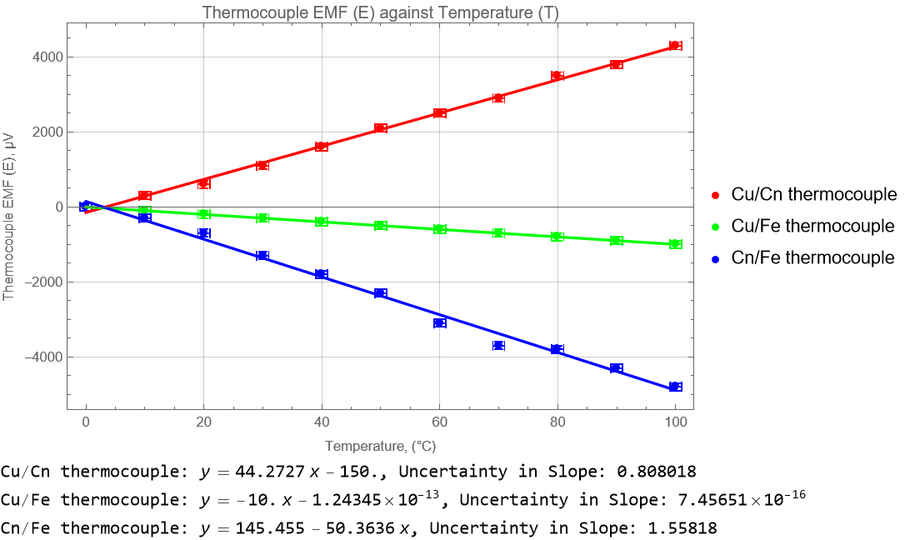

**Figure 6**: Graph of Thermocouple EMF (E) against Temperature (T).Top of Form

[Display by Mathematica: Appendix 2]

Based on the Results of Mathematica Programing,

For Cu/Cn thermocouple,

The experimental value of Seebeck coefficients, $α_{Cu/Cn}$ = $(44.27±0.81)$ µV °C⁻¹

The standard value of Seebeck coefficients, $α_{Cu/Cn}$ = 40.87 µV °C⁻¹,

The percentage discrepancies between the experimental and standard value

= $\left|\frac{44.27-40.87}{40.87}\right|× 100 \%$

= 8.32 $\%$

For Cu/Fe thermocouple,

The experimental value of Seebeck coefficients, $α_{Cu/Fe }$ = $(-10.00±0.00)$ µV °C⁻¹

The standard value of Seebeck coefficients, $α_{Cu/Fe }$ = -13.89 µV °C⁻¹

The percentage discrepancies between the experimental and standard value

= $\left|\frac{(-10.00)-(-13.89)}{-13.89}\right|× 100 \%$

= 28.01 $\%$

For Cn/Fe thermocouple,

The experimental value of Seebeck coefficients, $α_{Cn/Fe }$ = $(-50.36±1.56)$ µV °C⁻¹

The standard value of Seebeck coefficients, $α_{Cn/Fe }$ = -54.76 µV°C⁻¹

The percentage discrepancies between the experimental and standard value

= $\left|\frac{(-50.36)-(-54.76)}{-54.76}\right|× 100 \%$

= 8.04 $\%$

For the theoretical value;

By using the Law of Intermediate Metals;

For the thermocouple of Cu/Cn, $α_{Cu/Cn}$ = $α_{Cu/Fe }$ + $α_{Fe /Cn}$

= -10.0 + (50.36)

= 40.36 µV°C⁻¹

For the thermocouple of Cu/Fe, $α_{Cu/Fe }$ = $α_{Cu/Cn}$ + $α_{Cn/Fe }$

= 44.27 + (-50.36)

= -6.09 µV°C⁻¹

For the thermocouple of Cn/Fe, $α_{Cn/Fe }$ = $α_{Cn/Cu}$ + $α_{Cu/Fe }$

= -44.27 + (-10.0)

= -54.27 µV°C⁻¹

|  |  |  |  |  |
| --- | --- | --- | --- | --- |
| Seebeck coefficients of Thermocouple | Experimental Value  (µV°C⁻¹) | Theoretical Value  (µV°C⁻¹) | Standard Value  (µV°C⁻¹) | Percentage of discrepancy (%) |
| $$α_{Cu/Cn}$$ | $$(44.27±0.81)$$ | 40.36 | 40.87 | 8.31 |
| $$α_{Cu/Fe }$$ | $$(-10.00±0.00)$$ | -6.09 | -13.89 | 28.01 |
| $$α_{Cn/Fe }$$ | $$(-50.36±1.56)$$ | -54.27 | -54.76 | 8.04 |

**Table 3**: Seebeck coefficients of Thermocouple of various thermocouples.

**Part B**

|  |  |  |
| --- | --- | --- |
| **EMF of Cu/Cn,**  𝑬𝐂𝐮/𝐂𝐧 **(μV)** | **Corresponding**  **Temperature (**𝑻**, °C)** | **EMF of Cu/Fe,**  𝑬 **(μV)** |
| 1400 | 35 | -300 |
| 2400 | 58 | -500 |
| 3400 | 81 | -700 |
| 4400 | 103 | -900 |
| 5400 | 124 | -1000 |
| 6400 | 144 | -1100 |
| 7400 | 164 | -1200 |
| 8400 | 183 | -1300 |
| 9400 | 202 | -1300 |
| 10400 | 221 | -1400 |
| 11400 | 239 | -1400 |
| 12400 | 257 | -1400 |
| 13400 | 275 | -1400 |
| 14400 | 292 | -1400 |
| 15400 | 309 | -1400 |
| 16400 | 326 | -1300 |
| 17400 | 343 | -1300 |
| 18400 | 360 | -1200 |
| 19400 | 376 | -1100 |
| 20400 | 392 | -1000 |
| 21400 | 400 | -900 |

**Table 4**: EMF (𝐸) of the Cu/Fe thermocouple as a function of temperature (𝑇).

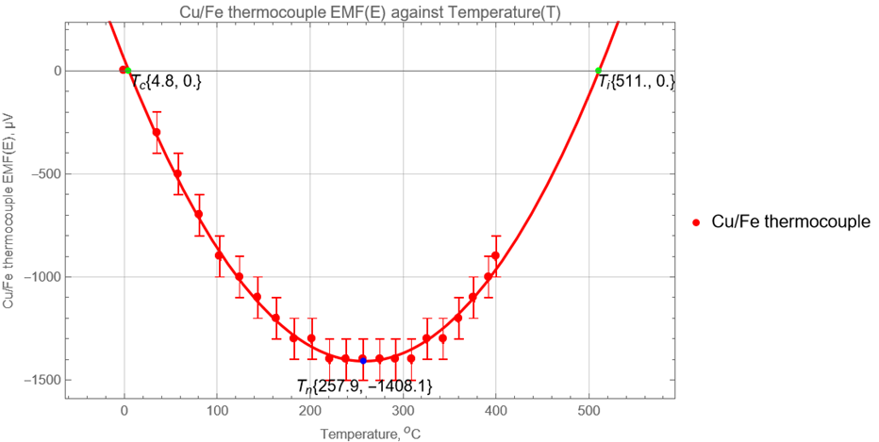

**Figure 7**: Original Graph of Thermocouple EMF (E) against Temperature (T) of Cu/Fe thermocouple.Top of Form

[Display by Mathematica: Appendix 3]

**Figure 8**: Shifted Graph of Thermocouple EMF (E) against Temperature (T) of Cu/Fe thermocouple.

[Display by Mathematica: Appendix 4]

To align with the theoretical principles, the graph depicting the relationship between Thermocouple EMF (E) and Temperature (T) for a Cu/Fe thermocouple has been adjusted. This modification ensures that the graph reflects the theory accurately, which states that the Critical temperature, $T_{c}$ should be zero when the Thermocouple EMF (E) is also zero. The revised graph provides a clearer and more accurate representation of the theoretical relationship between these variables.

Based on the graph,

The neutral temperature, $T_{n}$ = 253 ºC

The inverse temperature, $T_{i}$ = 506 ºC

The standard value of neutral temperature, $T_{n}$ = 285 ºC

The standard value of inverse temperature, $T_{i}$ = 570 ºC

The percentage discrepancies between the experimental and standard value of $T_{n}$

= $\left|\frac{253-285}{285}\right|× 100 \%$

= 11.23 $\%$

The percentage discrepancies between the experimental and standard value of $T_{i}$

= $\left|\frac{506-570}{570}\right|× 100 \%$

= 11.23 $\%$

|  |  |  |  |  |
| --- | --- | --- | --- | --- |
| Results obtained from Graph of Thermocouple EMF (E) against Temperature (T) of Cu/Fe thermocouple | | | | |
| Thermocouple | Neutral temperature, $T_{n}$ (ºC) | Percentage of discrepancy of ${ T}_{n}$ (%) | Inverse temperature, $T_{i}$ (ºC) | Percentage of discrepancy of ${ T}_{i} (\%)$ |
| $$α_{Cu/Fe }$$ | 253 | 11.23 | 506 | 11.23 |

**Table 5**: Results obtained from Graph of Thermocouple EMF (E) against Temperature (T) of Cu/Fe thermocouple

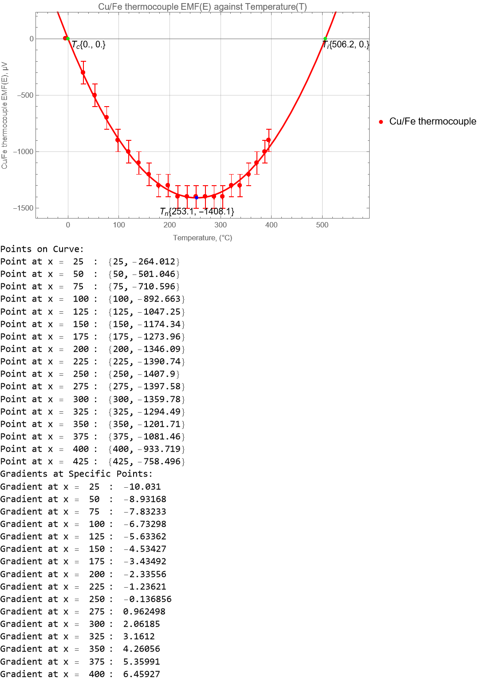**Figure 9**: Graph of Thermocouple EMF (E) against Temperature (T) of Cu/Fe thermocouple with coordinates of points on curve and gradient of the points on the curve.

[Display by Mathematica: Appendix 5]

Using Mathematica's functional code, the coordinates of points on the curve are determined, and the gradient at these points is calculated.

|  |  |  |  |  |  |  |
| --- | --- | --- | --- | --- | --- | --- |
| **Temperature,**  ***T***  **(**°𝐂**)** | 𝚫𝑻  **(°C)** | 𝚫𝑬  **(μV)** | | | 𝒅𝑬 𝚫𝑬  ≈  𝒅𝑻 𝚫𝑻  **(**𝛍𝐕 °𝐂−𝟏**)** | |
| 𝑬 (𝑻 + 𝟐𝟓) | 𝑬 (𝑻 - 𝟐𝟓) | 𝚫𝑬 | $$\frac{d E}{d T}$$ | $$\frac{∆E}{∆T}$$ |
| 25 | 50 | -501 | 0 | -501 | -10.03 | -10.02 |
| 50 | 50 | -711 | -264 | -447 | -8.93 | -8.94 |
| 75 | 50 | -893 | -501 | -392 | -7.83 | -7.84 |
| 100 | 50 | -1047 | -711 | -336 | -6.73 | -6.72 |
| 125 | 50 | -1174 | -893 | -281 | -5.63 | -5.62 |
| 150 | 50 | -1274 | -1047 | -227 | -4.53 | -4.54 |
| 175 | 50 | -1346 | -1174 | -172 | -3.43 | -3.44 |
| 200 | 50 | -1391 | -1274 | -117 | -2.34 | -2.34 |
| 225 | 50 | -1408 | -1346 | -62 | -1.24 | -1.24 |
| 250 | 50 | -1398 | -1391 | -7 | -0.14 | -0.14 |
| 275 | 50 | -1360 | -1408 | 48 | 0.96 | 0.96 |
| 300 | 50 | -1294 | -1398 | 104 | 2.06 | 2.08 |
| 325 | 50 | -1202 | -1360 | 158 | 3.16 | 3.16 |
| 350 | 50 | -1081 | -1294 | 213 | 4.26 | 4.26 |
| 375 | 50 | -934 | -1202 | 268 | 5.36 | 5.36 |
| 400 | 50 | -759 | -1081 | 322 | 6.46 | 6.44 |

**Table 6**: 𝑑𝐸/𝑑𝑇 as a function of 𝑇.

|  |  |  |
| --- | --- | --- |
| $$\frac{d E}{d T}$$ | $$\frac{∆E}{∆T}$$ | **Percentage of discrepancy between $\frac{d E}{d T} and$ $\frac{∆E}{∆T}$** |
| -10.03 | -10.02 | 0.10 |
| -8.93 | -8.94 | 0.11 |
| -7.83 | -7.84 | 0.13 |
| -6.73 | -6.72 | 0.15 |
| -5.63 | -5.62 | 0.18 |
| -4.53 | -4.54 | 0.22 |
| -3.43 | -3.44 | 0.29 |
| -2.34 | -2.34 | 0.00 |
| -1.24 | -1.24 | 0.00 |
| -0.14 | -0.14 | 0.00 |
| 0.96 | 0.96 | 0.00 |
| 2.06 | 2.08 | 0.97 |
| 3.16 | 3.16 | 0.00 |
| 4.26 | 4.26 | 0.00 |
| 5.36 | 5.36 | 0.00 |
| 6.46 | 6.44 | 0.31 |

**Table 7**: Percentage of discrepancy between $\frac{d E}{d T} and$ $\frac{∆E}{∆T}$

[Calculated by Excel: Appendix 6]

Based on the percentage of discrepancy between $\frac{d E}{d T} and$ $\frac{∆E}{∆T}$ ofall the certain points are smaller than 0.5%, It can sufficiently make an assumption that the $\frac{d E}{d T}$ is approximate to $\frac{∆E}{∆T}$ ( $\frac{d E}{d T}≈\frac{∆E}{∆T}$).

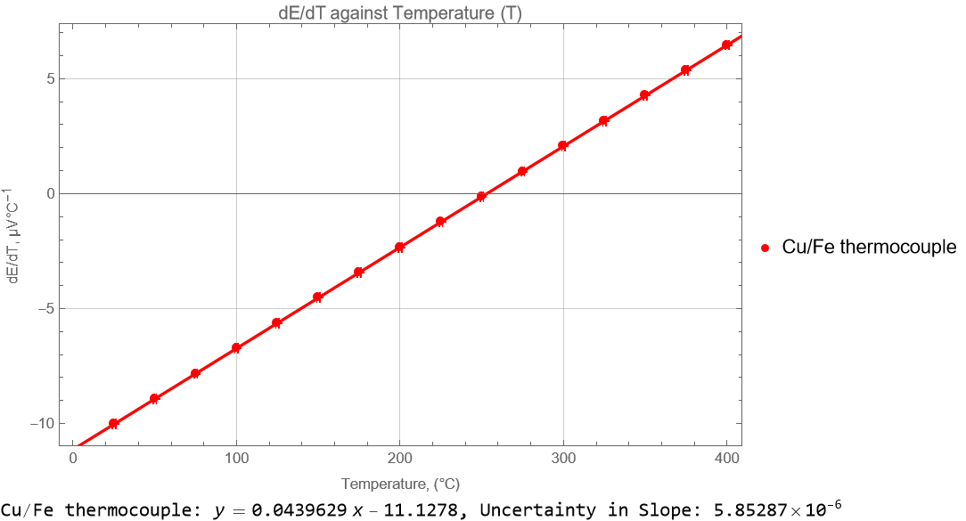

**Figure 10**: Graph of dE/dT against Temperature (T) of Cu/Fe thermocouple.

[Display by Mathematica: Appendix 7]

Given that the equation 𝐸 =𝛼𝑇 + $\frac{1}{2}$ 𝛽 $T^{2}$

$\frac{d E}{d T}$*= $\frac{d }{d T}$* (𝛼𝑇 + $\frac{1}{2}$ 𝛽 $T^{2}$)

$\frac{d E}{d T}$ =𝛼 + 𝛽*T*

$\frac{d E}{d T}$ = 𝛽*T* +𝛼

Since the graph is a linear graph with the general linear equation,

Y = mX + C

By comparing,

Gradient, m = 𝛽

Y-intercept, C= 𝛼

The value of gradient obtained by using the programing with Mathematica is

Gradient, m = 0.0439659

𝛽= 0.044 µV°C⁻¹

The value of Y-intercept obtained by using the programing with Mathematica is

Y-intercept, C = -11.1278

𝛼 = -11.13µV°C⁻¹

The neutral temperature, $T_{n}$ occurred when $\frac{d E}{d T}$ = 0,

𝛽 $T_{n}$ +𝛼 = 0

0.044 $T_{n}$-11.13 = 0

$T_{n}$ = $\frac{11.13}{0.044}$

$T_{n}$ = 253 °C

The inverse temperature, $T_{i}$,

$T_{i}$ = 2 $T_{n}$

$T_{i}$ = 2(253)

$T_{i}$ = 506 °C

The percentage discrepancies between the experimental and standard value of $T_{n}$

= $\left|\frac{253-285}{285}\right|× 100 \%$

= 11.23 $\%$

The percentage discrepancies between the experimental and standard value of $T_{i}$

= $\left|\frac{506-570}{570}\right|× 100 \%$

= 11.23 $\%$

|  |  |  |  |  |
| --- | --- | --- | --- | --- |
| Results obtained from Graph of dE/dT against Temperature (T) of Cu/Fe thermocouple | | | | |
| Thermocouple | Neutral temperature, $T_{n}$ (ºC) | Percentage of discrepancy of ${ T}_{n}$ (%) | Inverse temperature, $T_{i}$ (ºC) | Percentage of discrepancy of ${ T}_{i} (\%)$ |
| $$α_{Cu/Fe }$$ | 253 | 11.23 | 506 | 11.23 |

**Table 8**: Results obtained from Graph of dE/dT against Temperature (T) of Cu/Fe thermocouple.

|  |  |  |
| --- | --- | --- |
| **Temperature,**  𝑻 **(**°𝐂**)** | **EMF,**  𝑬 **(μV)** | 𝑬/𝑻 **(**𝛍𝐕 °𝐂−𝟏**)** |
| 25 | -264 | -10.56 |
| 50 | -501 | -10.02 |
| 75 | -711 | -9.48 |
| 100 | -893 | -8.93 |
| 125 | -1047 | -8.38 |
| 150 | -1174 | -7.83 |
| 175 | -1274 | -7.28 |
| 200 | -1346 | -6.73 |
| 225 | -1391 | -6.18 |
| 250 | -1408 | -5.63 |
| 275 | -1398 | -5.08 |
| 300 | -1360 | -4.53 |
| 325 | -1294 | -3.98 |
| 350 | -1202 | -3.43 |
| 375 | -1081 | -2.88 |
| 400 | -934 | -2.34 |

**Table 9**: Values of 𝐸/𝑇 for their corresponding temperatures 𝑇.

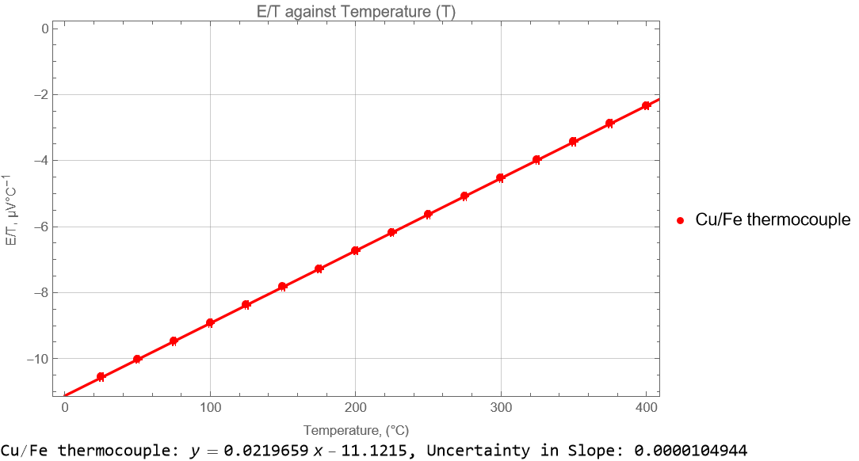[Calculated by Excel: Appendix 8]

**Figure 11**: Graph of E/T against Temperature (T) of Cu/Fe thermocouple.

[Display by Mathematica: Appendix 9]

Given that the equation 𝐸 =𝛼𝑇 + $\frac{1}{2}$ 𝛽 $T^{2}$

$E$*=*𝑇(𝛼 + $\frac{1}{2}$ 𝛽*T*)

$\frac{E}{T}$ =𝛼 + $\frac{1}{2}$ 𝛽*T*

$\frac{E}{T}$*= $\frac{1}{2}$* 𝛽*T* *+* 𝛼

Since the graph is a linear graph with the general linear equation,

Y = mX + C

By comparing,

Gradient, m = $\frac{1}{2}$ 𝛽

Y-intercept, C= 𝛼

The value of gradient obtained by using the programing with Mathematica is

Gradient, m = 0.0219659

$\frac{1}{2}$ 𝛽*=* 0.0219659

𝛽= 2 $×$ 0.0219659

𝛽= 0.044 µV°C⁻¹

The value of Y-intercept obtained by using the programing with Mathematica is

Y-intercept, C = -11.1215

𝛼 = -11.12 µV°C⁻¹

The inverse temperature, $T_{i}$ occurred when $\frac{ E}{T}$ = 0,

𝐸 =𝛼𝑇 + $\frac{1}{2}$ 𝛽 $T^{2}$

$E$*=*𝑇(𝛼 + $\frac{1}{2}$ 𝛽*T*)

$\frac{E}{T}$ =𝛼 + $\frac{1}{2}$ 𝛽*T*

𝛼 + $\frac{1}{2}$ 𝛽 $T_{i}$ = 0

$\frac{1}{2}×2× 0.0219659×$ $T_{i}-11.12$ = 0

$T_{i}$ = 11.12 $÷0.0219659$

$T_{i}$ = 506

$T_{i}$ = 506 °C

The neutral temperature, $T_{n}$,

$T_{n}{=\frac{1}{2}T}_{i}$

$T_{n}=\frac{1}{2}×506$

$T_{n}$ = 253 °C

The percentage discrepancies between the experimental and standard value of $T_{n}$

= $\left|\frac{253-285}{285}\right|× 100 \%$

= $11.23 \%$

The percentage discrepancies between the experimental and standard value of $T_{i}$

= $\left|\frac{506-570}{570}\right|× 100 \%$

= $11.23 \%$

|  |  |  |  |  |
| --- | --- | --- | --- | --- |
| Results obtained from Graph of E/T against Temperature (T) of Cu/Fe thermocouple | | | | |
| Thermocouple | Neutral temperature, $T_{n}$ (ºC) | Percentage of discrepancy of ${ T}_{n}$ (%) | Inverse temperature, $T_{i}$ (ºC) | Percentage of discrepancy of ${ T}_{i} (\%)$ |
| $$α_{Cu/Fe }$$ | 253 | 11.23 | 506 | 11.23 |

|  |  |  |  |  |
| --- | --- | --- | --- | --- |
| Thermocouple | Neutral temperature, $T_{n}$ (ºC) | Percentage of discrepancy of ${ T}_{n}$ (%) | Inverse temperature, $T_{i}$ (ºC) | Percentage of discrepancy of ${ T}_{i} (\%)$ |
| Results obtained from Graph of Thermocouple EMF (E) against Temperature (T) of Cu/Fe thermocouple | | | | |
| $$α_{Cu/Fe }$$ | 253 | 11.23 | 506 | 11.23 |
| Results obtained from Graph of dE/dT against Temperature (T) of Cu/Fe thermocouple | | | | |
| $$α_{Cu/Fe }$$ | 253 | 11.23 | 506 | 11.23 |
| Results obtained from Graph of E/T against Temperature (T) of Cu/Fe thermocouple | | | | |
| $$α_{Cu/Fe }$$ | 253 | 11.23 | 506 | 11.23 |

**Table 10**: Results obtained from Graph of E/T against Temperature (T) of Cu/Fe thermocouple.

**Table 11**: Results of Neutral and Inverse temperature with Percentage of discrepancy obtained from various graphing methods.

**Part C**

|  |  |  |  |  |  |  |
| --- | --- | --- | --- | --- | --- | --- |
| **Material** | 𝒉 ($±0.001$ cm) | 𝒅𝟏 ($±0.001$ cm) | 𝒅𝟐 ($±0.001$ cm) | 𝒕𝐚  ($±0.01$ s) | 𝒎𝐚  ($±0.1$ g) | 𝒕  ($±0.01$ s) |
| Masonite | 0.850 | 9.058 | 6.086 | 600.00 | 19.0 | 600.00 |
| Wood | 0.750 | 6.400 | 5.600 | 600.00 | 14.7 | 600.00 |
| Lexan | 0.550 | 6.065 | 5.400 | 600.25 | 21.3 | 600.15 |
| Rock | 1.280 | 6.830 | 5.120 | 600.00 | 21.0 | 600.00 |
| Grass | 0.700 | 6.180 | 5.200 | 600.00 | 20.1 | 600.00 |
| **Material** | 𝒎𝐰  ($±0.1$ g) | 𝒅𝐚𝐯𝐠 (cm) | 𝑨 (c $m^{2}$) | 𝑹𝐚(g $s^{-1}$) | 𝑹(g $s^{-1}$) | 𝑹o(g $s^{-1}$) |
| Masonite | 29.0 | 7.5720 | 45.03095 | 0.031666667 | 0.048333333 | 0.016666667 |
| Wood | 18.2 | 6.0000 | 28.27433 | 0.024500000 | 0.030333333 | 0.005833333 |
| Lexan | 36.7 | 5.7325 | 25.80941 | 0.035485214 | 0.061151379 | 0.025666164 |
| Rock | 26.7 | 5.9750 | 28.03921 | 0.035000000 | 0.044500000 | 0.009500000 |
| Grass | 26.6 | 5.6900 | 25.42813 | 0.033500000 | 0.044333333 | 0.010833333 |

**Table 12**: Data for Part C.

The experimental thermal conductivity, 𝑘 of each sample in *Cal ${cm}^{-1}s^{-1}{°C}^{-1}$*, using the formula:

$k=\frac{R_{o}h×80 cal g^{-1} }{A∆T}$

​

taking ΔT as the boiling point of water at 1 atmospheric pressure.

|  |  |  |  |  |  |
| --- | --- | --- | --- | --- | --- |
| **Material** | experimental thermal conductivity, k  ($×{10}^{-4}$*Cal ${cm}^{-1}s^{-1}{°C}^{-1})$* | Standard thermal conductivity, $k_{o}$ ($×{10}^{-4}$*Cal ${cm}^{-1}s^{-1}{°C}^{-1})$* | | Percentage of discrepancy of experimental and standard thermal conductivity (%) | |
| Masonite | 2.52 $±$ 0.05 | 1.13 |  | 122.72 |  |
| Wood | 1.24 $±$ 0.07 | 2.06 | 3.30 | 39.91 | 62.49 |
| Lexan | 4.38 $±$ 0.06 | 4.60 |  | 4.88 |  |
| Rock | 3.47 $±$ 0.12 | 10.30 |  | 66.32 |  |
| Grass | 2.39 $±$ 0.07 | 17.20 | 20.60 | 86.13 | 88.42 |

**Table 13**: Results of experimental thermal conductivity, k and Percentage of discrepancy of different material.

All the calculations for obtained the results of experimental thermal conductivity, uncertainty, and percentage of discrepancy of experimental and standard thermal conductivity is conducted by using Excel.

[Calculated by Excel: Appendix 10]

**Figure 12**: Derivations of the formula used to find the uncertainty of experimental thermal conductivity, k (Written by Latex).

[Display by Latex: Appendix 11]

# DISCUSSION AND CONCLUSION

**DISCUSSION**

In our PART A experiment, we derived the experimental values for each thermocouple from the slope of Graph of Thermocouple EMF (E) against Temperature (T) [Figure 6]. We determined the experimental Seebeck coefficient, $α_{Cu/Cn }$ for Copper/Constantan (Cu/Cn) thermocouple as $(44.27±0.81)$ µV°C⁻¹, with a discrepancy of 8.32% from the standard value. However, for Copper/Iron (Cu/Fe) thermocouple, the experimental $α_{Cu/Fe }$ was $(-10.00±0.00)$ µV°C⁻¹, deviating significantly by 28.01% from the expected standard. Similarly, the Constantan/Iron (Cn/Fe) thermocouple showed an experimental $α_{Cn/Fe }$ of $(-50.36±1.56)$ µV°C⁻¹, with an 8.04% discrepancy.

These results indicate that while the discrepancies for Cu/Cn and Cn/Fe thermocouples are within an acceptable 10% range of discrepancy, the error margin for Cu/Fe exceeds this limit, pointing to significant experimental errors. Discrepancies in the Seebeck coefficient could be due to inaccurate temperature measurements, non-ideal thermocouple behavior, or electromagnetic interference. The purity and condition of the metals used in the thermocouples might not be consistent. Possible sources of these errors also include non-uniform water temperature during heating, a result of insufficient stirring or uneven heat distribution. Additionally, the placement of the thermometer might have contributed to the errors; if placed too low, it could have touched the container's bottom, affecting the readings.

To mitigate such errors in future experiments, it is crucial to use thermocouples made from high-purity metals and ensure consistent manufacturing processes. During the experiment ensure uniform water temperature by constant stirring during the heating process and to position the thermometer correctly, avoiding contact with the container bottom. Additionally, to minimize heat loss and prevent parallax errors, it would be advisable to conduct the experiment in a controlled environment, such as turning off fans and carefully reading the thermometer.

Another, PART B experiment yielded three identical sets of values, each derived from a different graph. From the Graphs of Thermocouple EMF (E) against Temperature (T) of Cu/Fe thermocouple, dE/dT against Temperature (T) of Cu/Fe thermocouple and E/T against Temperature (T) of Cu/Fe thermocouple, we determined the neutral temperature, $T_{i}$ and inverse temperature, $T_{n}$ to be 253 ⁰C and 506 ⁰C, with the percentage discrepancy of 11.23%.

The values for the neutral temperature across different graphs showed consistency. However, the presence of experimental errors that affected the outcomes cannot be overlooked. Rapid temperature changes could lead to non-equilibrium states, affecting the EMF readings. For instance, the equipment used, such as the multimeter, may have had sensitivity issues or not been functioning optimally. Additionally, the irregular shape of the rock used to maintain the temperature might have caused the thermocouples to displace from the heater. Another potential source of error could be the floating of the cold end in ice water as the ice melted.

To improve the accuracy of future experiments, several corrective measures should be implemented. Slow down the rate of temperature change to allow the system to reach equilibrium at each step. Ensuring the hot junction is in direct contact with the heater and maintaining the cold end at a steady 0⁰C by regularly adding ice are crucial steps. Also, taking voltmeter readings promptly and switching off any fans to reduce air movement will help in minimizing errors and achieving more reliable results.

In PART C experiment, we measured the thermal conductivity (k) of various materials:

Masonite: $k_{Masonite}=$ [($2.52±0.05$) $×{10}^{-4}$*Cal ${cm}^{-1}s^{-1}{°C}^{-1}$*, 122.72 % discrepancy];

Wood: $k_{Wood}=$ [(1.24 $±$ 0.07) $×{10}^{-4}$*Cal ${cm}^{-1}s^{-1}{°C}^{-1}$*, (39.91~62.49) % discrepancy];

Lexan: $k_{Lexan}=$ [(4.38 $±$ 0.06) $×{10}^{-4}$*Cal ${cm}^{-1}s^{-1}{°C}^{-1}$*, 4.88 % discrepancy];

Rock: $k_{Rock}=$ [(3.47 $±$ 0.12) $×{10}^{-4}$*Cal ${cm}^{-1}s^{-1}{°C}^{-1}$*, 66.32 % discrepancy];

Glass: $k_{Glass}=$ [(2.39 $±$ 0.07) $×{10}^{-4}$*Cal ${cm}^{-1}s^{-1}{°C}^{-1}$*, (86.13~88.42) % discrepancy].

These large discrepancies suggest the presence of major experimental errors.

One notable source of error was the inconsistency in the ice block's diameter, as it did not melt uniformly. This irregular melting affected the accuracy of diameter measurements taken at various points. It's crucial to ensure consistent measurement points and to handle the Vernier calliper delicately to avoid marking or scratching the ice, as these marks could deepen with melting and skew results.

Furthermore, the melting of ice throughout the experiment necessitated rapid post-experiment measurements to minimize errors due to changing diameters. Another issue was potential leakage between the sample and the container's surface.

To mitigate these errors in future experiments, several precautionary steps are recommended. First, ensuring all equipment and apparatus are in optimal condition is paramount. Any equipment with known zero errors should be either recorded for correction or replaced. Multiple measurements should be taken to calculate an average, enhancing accuracy. Environmental factors, such as air movement or humidity, should be controlled by turning off fans. Careful reading techniques must be employed to avoid parallax errors. Finally, ensuring the water channel is dry before starting a new experiment will help in obtaining more accurate results.

**CONCLUSION**

From this experiment, concluded that Seebeck coefficient of thermocouples :

$α_{Cu/Cn}=(44.27±0.81)$ µV°C⁻¹, with an 8.32% discrepancy;

$α_{Cu/Fe }=(-10.00±0.00)$ µV°C⁻¹, with an 28.01% discrepancy;

$α_{Cn/Fe }=(-50.36±1.56)$ µV°C⁻¹, with an 8.04% discrepancy.

Through multiple graphs indicated $T_{n}$ = 253°C and $T_{i}$ = 506°C with a discrepancy of 11.23% for Cu/Fe thermocouple. The thermal conductivity, k of various materials:

Masonite: $k_{Masonite}=$ [($2.52±0.05$) $×{10}^{-4}$*Cal ${cm}^{-1}s^{-1}{°C}^{-1}$*, 122.72 % discrepancy];

Wood: $k_{Wood}=$ [(1.24 $±$ 0.07) $×{10}^{-4}$*Cal ${cm}^{-1}s^{-1}{°C}^{-1}$*, (39.91~62.49) % discrepancy];

Lexan: $k_{Lexan}=$ [(4.38 $±$ 0.06) $×{10}^{-4}$*Cal ${cm}^{-1}s^{-1}{°C}^{-1}$*, 4.88 % discrepancy];

Rock: $k_{Rock}=$ [(3.47 $±$ 0.12) $×{10}^{-4}$*Cal ${cm}^{-1}s^{-1}{°C}^{-1}$*, 66.32 % discrepancy];

Glass: $k_{Glass}=$ [(2.39 $±$ 0.07) $×{10}^{-4}$*Cal ${cm}^{-1}s^{-1}{°C}^{-1}$*, (86.13~88.42) % discrepancy].

# REFERENCES

1. Lewis, K. (2017). *Thermocouple Laws.* Retrieved 4 Aug 2021 from [sciencing.com.](https://sciencing.com/about-5405627-thermocouple.html)
2. Northwestern University (n. d.). *Brief History of Thermoelectrics.* Retrieved 4 Aug 2021 from [thermoelectrics.matsci.northestern.edu.](http://thermoelectrics.matsci.northwestern.edu/thermoelectrics/history.html)
3. Quest Tutorials (n. d.). *Thermoelectric Effect of Current*. Retrieved 4 Aug 2021 from [questtutorials.com.](https://www.questtutorials.com/media/static/xii/physics/03_Thermal%20and%20Chemical%20effects%20of%20current/04_Thermoelectric%20effect%20of%20current.htm)
4. Study.com (n. d.). What is Neutral Temperature? Retrieved 4 Aug 2021 from [study.com.](https://study.com/academy/answer/what-is-neutral-temperature.html)
5. PASCO (1987). Instruction Manual for the *Thermal Conductivity Apparatus* (TD-8561).

# APPENDICES

**Appendix 1:**

**Table A1:** Thermoelectric voltage (mV) for Cu/Cn thermocouple hot junction at temperature 0–400 °C, reference junction at 0 °C.

|  |  |  |  |  |  |  |  |  |  |  |
| --- | --- | --- | --- | --- | --- | --- | --- | --- | --- | --- |
| **Temperature**  **(°C)** | **0** | **1** | **2** | **3** | **4** | **5** | **6** | **7** | **8** | **9** |
| **0** | 0.000 | 0.039 | 0.078 | 0.117 | 0.156 | 0.195 | 0.234 | 0.273 | 0.312 | 0.352 |
| **10** | 0.391 | 0.431 | 0.470 | 0.510 | 0.549 | 0.589 | 0.629 | 0.669 | 0.709 | 0.749 |
| **20** | 0.790 | 0.830 | 0.870 | 0.911 | 0.951 | 0.992 | 1.033 | 1.074 | 1.114 | 1.155 |
| **30** | 1.196 | 1.238 | 1.279 | 1.320 | 1.362 | 1.403 | 1.445 | 1.486 | 1.528 | 1.570 |
| **40** | 1.612 | 1.654 | 1.696 | 1.738 | 1.780 | 1.823 | 1.865 | 1.908 | 1.950 | 1.993 |
| **50** | 2.036 | 2.079 | 2.122 | 2.165 | 2.208 | 2.251 | 2.294 | 2.338 | 2.381 | 2.425 |
| **60** | 2.468 | 2.512 | 2.556 | 2.600 | 2.643 | 2.687 | 2.732 | 2.776 | 2.820 | 2.864 |
| **70** | 2.909 | 2.953 | 2.998 | 3.043 | 3.087 | 3.132 | 3.177 | 3.222 | 3.267 | 3.312 |
| **80** | 3.358 | 3.403 | 3.448 | 3.494 | 3.539 | 3.585 | 3.631 | 3.677 | 3.722 | 3.768 |
| **90** | 3.814 | 3.860 | 3.907 | 3.953 | 3.999 | 4.046 | 4.092 | 4.138 | 4.185 | 4.232 |
| **100** | 4.279 | 4.325 | 4.372 | 4.419 | 4.466 | 4.513 | 4.561 | 4.608 | 4.655 | 4.702 |
| **110** | 4.750 | 4.798 | 4.845 | 4.893 | 4.941 | 4.988 | 5.036 | 5.084 | 5.132 | 5.180 |
| **120** | 5.228 | 5.277 | 5.325 | 5.373 | 5.422 | 5.470 | 5.519 | 5.567 | 5.616 | 5.665 |
| **130** | 5.714 | 5.763 | 5.812 | 5.861 | 5.910 | 5.959 | 6.008 | 6.057 | 6.107 | 6.156 |
| **140** | 6.206 | 6.255 | 6.305 | 6.355 | 6.404 | 6.454 | 6.504 | 6.554 | 6.604 | 6.654 |
| **150** | 6.704 | 6.754 | 6.805 | 6.855 | 6.905 | 6.956 | 7.006 | 7.057 | 7.107 | 7.158 |
| **160** | 7.209 | 7.260 | 7.310 | 7.361 | 7.412 | 7.463 | 7.515 | 7.566 | 7.617 | 7.668 |
| **170** | 7.720 | 7.771 | 7.823 | 7.874 | 7.926 | 7.977 | 8.029 | 8.081 | 8.133 | 8.185 |
| **180** | 8.237 | 8.289 | 8.341 | 8.393 | 8.445 | 8.497 | 8.550 | 8.602 | 8.654 | 8.707 |
| **190** | 8.759 | 8.812 | 8.865 | 8.917 | 8.970 | 9.023 | 9.076 | 9.129 | 9.182 | 9.235 |
| **200** | 9.288 | 9.341 | 9.395 | 9.448 | 9.501 | 9.555 | 9.608 | 9.662 | 9.715 | 9.769 |
| **210** | 9.822 | 9.876 | 9.930 | 9.984 | 10.038 | 10.092 | 10.146 | 10.200 | 10.254 | 10.308 |
| **220** | 10.362 | 10.417 | 10.471 | 10.525 | 10.580 | 10.634 | 10.689 | 10.743 | 10.798 | 10.853 |
| **230** | 10.907 | 10.962 | 11.017 | 11.072 | 11.127 | 11.182 | 11.237 | 11.292 | 11.347 | 11.403 |
| **240** | 11.458 | 11.513 | 11.569 | 11.624 | 11.680 | 11.735 | 11.791 | 11.846 | 11.902 | 11.958 |
| **250** | 12.013 | 12.069 | 12.125 | 12.181 | 12.237 | 12.292 | 12.349 | 12.405 | 12.461 | 12.518 |
| **260** | 12.574 | 12.630 | 12.687 | 12.743 | 12.799 | 12.856 | 12.912 | 12.969 | 13.026 | 13.082 |
| **270** | 13.139 | 13.196 | 13.253 | 13.310 | 13.366 | 13.423 | 13.480 | 13.537 | 13.595 | 13.652 |
| **280** | 13.709 | 13.766 | 13.823 | 13.881 | 13.938 | 13.995 | 14.053 | 14.110 | 14.168 | 14.226 |
| **290** | 14.283 | 14.341 | 14.399 | 14.456 | 14.514 | 14.572 | 14.630 | 14.688 | 14.746 | 14.804 |
| **300** | 14.862 | 14.920 | 14.978 | 15.036 | 15.095 | 15.153 | 15.211 | 15.270 | 15.328 | 15.386 |
| **310** | 15.445 | 15.503 | 15.562 | 15.621 | 15.679 | 15.738 | 15.797 | 15.856 | 15.914 | 15.973 |
| **320** | 16.032 | 16.091 | 16.150 | 16.209 | 16.268 | 16.327 | 16.387 | 16.446 | 16.505 | 16.564 |
| **330** | 16.624 | 16.683 | 16.742 | 16.802 | 16.861 | 16.921 | 16.980 | 17.040 | 17.100 | 17.159 |
| **340** | 17.219 | 17.279 | 17.339 | 17.399 | 17.458 | 17.518 | 17.578 | 17.638 | 17.698 | 17.759 |
| **350** | 17.819 | 17.879 | 17.939 | 17.999 | 18.060 | 18.120 | 18.180 | 18.241 | 18.301 | 18.362 |
| **360** | 18.422 | 18.483 | 18.543 | 18.604 | 18.665 | 18.725 | 18.786 | 18.847 | 18.908 | 18.969 |
| **370** | 19.030 | 19.091 | 19.152 | 19.213 | 19.274 | 19.335 | 19.396 | 19.457 | 19.518 | 19.579 |
| **380** | 19.641 | 19.702 | 19.763 | 19.825 | 20.886 | 20.947 | 20.009 | 20.070 | 20.132 | 20.193 |
| **390** | 20.255 | 20.317 | 20.378 | 20.440 | 20.502 | 20.563 | 20.625 | 20.687 | 20.748 | 20.810 |
| **400** | 20.872 |  |  |  |  |  |  |  |  |  |

**Appendix 2:**

**Figure 6: Graph of Thermocouple EMF (E) against Temperature (T).**

(*Define the datasets*)

t1 = {{0, 0}, {10, 300}, {20, 600}, {30, 1100}, {40, 1600}, {50,

2100}, {60, 2500}, {70, 2900}, {80, 3500}, {90, 3800}, {100,

4300}};

t2 = {{0,

0}, {10, -100}, {20, -200}, {30, -300}, {40, -400}, {50, -500}, \

{60, -600}, {70, -700}, {80, -800}, {90, -900}, {100, -1000}};

t3 = {{0,

0}, {10, -300}, {20, -700}, {30, -1300}, {40, -1800}, {50, \

-2300}, {60, -3100}, {70, -3700}, {80, -3800}, {90, -4300}, {100, \

-4800}};

t1error = {

{Around[0, 1], Around[0, 100]},

{Around[10, 1], Around[300, 100]},

{Around[20, 1], Around[600, 100]},

{Around[30, 1], Around[1100, 100]},

{Around[40, 1], Around[1600, 100]},

{Around[50, 1], Around[2100, 100]},

{Around[60, 1], Around[2500, 100]},

{Around[70, 1], Around[2900, 100]},

{Around[80, 1], Around[3500, 100]},

{Around[90, 1], Around[3800, 100]},

{Around[100, 1], Around[4300, 100]}};

t2error = {

{Around[0, 1], Around[0, 100]},

{Around[10, 1], Around[-100, 100]},

{Around[20, 1], Around[-200, 100]},

{Around[30, 1], Around[-300, 100]},

{Around[40, 1], Around[-400, 100]},

{Around[50, 1], Around[-500, 100]},

{Around[60, 1], Around[-600, 100]},

{Around[70, 1], Around[-700, 100]},

{Around[80, 1], Around[-800, 100]},

{Around[90, 1], Around[-900, 100]},

{Around[100, 1], Around[-1000, 100]}};

t3error = {

{Around[0, 1], Around[0, 100]},

{Around[10, 1], Around[-300, 100]},

{Around[20, 1], Around[-700, 100]},

{Around[30, 1], Around[-1300, 100]},

{Around[40, 1], Around[-1800, 100]},

{Around[50, 1], Around[-2300, 100]},

{Around[60, 1], Around[-3100, 100]},

{Around[70, 1], Around[-3700, 100]},

{Around[80, 1], Around[-3800, 100]},

{Around[90, 1], Around[-4300, 100]},

{Around[100, 1], Around[-4800, 100]}};

(*Fit linear models to the data*)

fitt1 = LinearModelFit[t1, x, x];

fitt2 = LinearModelFit[t2, x, x];

fitt3 = LinearModelFit[t3, x, x];

(*Extracting uncertainties in the slope of each fit*)

uncertainty1 = fitt1["ParameterTableEntries"][[2, 2]];

uncertainty2 = fitt2["ParameterTableEntries"][[2, 2]];

uncertainty3 = fitt3["ParameterTableEntries"][[2, 2]];

(*Extract equations as strings*)

eq1 = ToString[TraditionalForm[y == fitt1["BestFit"]]];

eq2 = ToString[TraditionalForm[y == fitt2["BestFit"]]];

eq3 = ToString[TraditionalForm[y == fitt3["BestFit"]]];

(*Existing code for plotting*)Column[{combinedPlot =

Show[ListPlot[{t1error, t2error, t3error},

PlotStyle -> {Red, Green, Blue},

PlotLegends -> {"Cu/Cn thermocouple", "Cu/Fe thermocouple",

"Cn/Fe thermocouple"}],

Plot[{fitt1[x], fitt2[x], fitt3[x]}, {x, 0, 100},

PlotStyle -> {Red, Green, Blue}], Frame -> True,

FrameLabel -> {"Temperature, (°C)", "Thermocouple EMF (E), µV"},

GridLines -> Automatic,

PlotLabel -> "Thermocouple EMF (E) against Temperature (T)",

ImageSize -> 500];

(*Displaying the results*)

Column[{combinedPlot,

Row[{"Cu/Cn thermocouple: ", eq1, ", Uncertainty in Slope: ",

uncertainty1}],

Row[{"Cu/Fe thermocouple: ", eq2, ", Uncertainty in Slope: ",

uncertainty2}],

Row[{"Cn/Fe thermocouple: ", eq3, ", Uncertainty in Slope: ",

uncertainty3}]}]

}

]

**Appendix 3:**

**Figure 7**: Original Graph of Thermocouple EMF (E) against Temperature (T) of Cu/Fe thermocouple

(*graph before shifted*)

(*Data and Error Definitions*)

t1 = {{0,

0}, {35, -300}, {58, -500}, {81, -700}, {103, -900}, {124, \

-1000}, {144, -1100}, {164, -1200}, {183, -1300}, {202, -1300}, {221, \

-1400}, {239, -1400}, {257, -1400}, {275, -1400}, {292, -1400}, {309, \

-1400}, {326, -1300}, {343, -1300}, {360, -1200}, {376, -1100}, {392, \

-1000}, {400, -900}};

(*Define the error bar*)

t1error = {{Around[0, 0], Around[0, 0]},

{Around[35, 0.5], Around[-300, 100]},

{Around[58, 0.5], Around[-500, 100]},

{Around[81, 0.5], Around[-700, 100]},

{Around[103, 0.5], Around[-900, 100]},

{Around[124, 0.5], Around[-1000, 100]},

{Around[144, 0.5], Around[-1100, 100]},

{Around[164, 0.5], Around[-1200, 100]},

{Around[183, 0.5], Around[-1300, 100]},

{Around[202, 0.5], Around[-1300, 100]},

{Around[221, 0.5], Around[-1400, 100]},

{Around[239, 0.5], Around[-1400, 100]},

{Around[257, 0.5], Around[-1400, 100]},

{Around[275, 0.5], Around[-1400, 100]},

{Around[292, 0.5], Around[-1400, 100]},

{Around[309, 0.5], Around[-1400, 100]},

{Around[326, 0.5], Around[-1300, 100]},

{Around[343, 0.5], Around[-1300, 100]},

{Around[360, 0.5], Around[-1200, 100]},

{Around[376, 0.5], Around[-1100, 100]},

{Around[392, 0.5], Around[-1000, 100]},

{Around[400, 0.5], Around[-900, 100]}};

(*Curve Fitting*)

x1 = t1[[All, 1]];

y1 = t1[[All, 2]];

fit1 = Fit[Transpose[{x1, y1}], {1, x, x^2}, x];

(*Finding Intersection Points with Y=0 Line*)

solutions = NSolve[fit1 == 0, x];

intersectionPoints = {#, 0} & /@ (x /. solutions);

(*Finding the Minimum Point*)

minX = x /. Last[FindMinimum[fit1, {x, 0}]];

minY = fit1 /. x -> minX;

minPoint = {minX, minY};

(*Labeling Function*)

labelPoint[pt_, label_, offset_] :=

Text[Style[label <> ToString[Round[pt, 0.1]], Black, 12], pt + offset]

(*Plotting*)

Show[ListPlot[{t1}, PlotStyle -> {Red}],

ListPlot[{t1error}, PlotStyle -> {Red},

PlotLegends -> {"Cu/Fe thermocouple"}],

Plot[{fit1}, {x, -100, 700}, PlotStyle -> {Red}],

Graphics[{Blue, PointSize[0.01], Point[minPoint],

labelPoint[minPoint,

"\!\(\*SubscriptBox[\(T\), \(n\)]\)", {0, -120}]}],

Graphics[{Green, PointSize[0.01], Point[intersectionPoints],

labelPoint[intersectionPoints[[1]],

"\!\(\*SubscriptBox[\(T\), \(c\)]\)", {40, -50}],

labelPoint[intersectionPoints[[2]],

"\!\(\*SubscriptBox[\(T\), \(i\)]\)", {40, -50}]}], Frame -> True,

FrameLabel -> {"Temperature,\!\(\*SuperscriptBox[\(\\\ \), \

\(o\)]\)C", "Cu/Fe thermocouple EMF(E), µV"}, GridLines -> Automatic,

PlotLabel -> "Cu/Fe thermocouple EMF(E) against Temperature(T)",

ImageSize -> 500, PlotRange -> {{-50, 580}, {200, -1500}}]

**Appendix 4:**

**Figure 8**: Shifted Graph of Thermocouple EMF (E) against Temperature (T) of Cu/Fe thermocouple.

(*graph after shif*)

(*Data and Error Definitions with Shift*)

t1 = {{0 - 4.8,

0}, {35 - 4.8, -300}, {58 - 4.8, -500}, {81 - 4.8, -700}, {103 -

4.8, -900}, {124 - 4.8, -1000}, {144 - 4.8, -1100}, {164 -

4.8, -1200}, {183 - 4.8, -1300}, {202 - 4.8, -1300}, {221 -

4.8, -1400}, {239 - 4.8, -1400}, {257 - 4.8, -1400}, {275 -

4.8, -1400}, {292 - 4.8, -1400}, {309 - 4.8, -1400}, {326 -

4.8, -1300}, {343 - 4.8, -1300}, {360 - 4.8, -1200}, {376 -

4.8, -1100}, {392 - 4.8, -1000}, {400 - 4.8, -900}};

(*Adjust t1error by Subtracting 4.8 from Each x-value*)

t1error = {{Around[0 - 4.8, 0], Around[0, 0]}, {Around[35 - 4.8, 0.5],

Around[-300, 100]}, {Around[58 - 4.8, 0.5],

Around[-500, 100]}, {Around[81 - 4.8, 0.5],

Around[-700, 100]}, {Around[103 - 4.8, 0.5],

Around[-900, 100]}, {Around[124 - 4.8, 0.5],

Around[-1000, 100]}, {Around[144 - 4.8, 0.5],

Around[-1100, 100]}, {Around[164 - 4.8, 0.5],

Around[-1200, 100]}, {Around[183 - 4.8, 0.5],

Around[-1300, 100]}, {Around[202 - 4.8, 0.5],

Around[-1300, 100]}, {Around[221 - 4.8, 0.5],

Around[-1400, 100]}, {Around[239 - 4.8, 0.5],

Around[-1400, 100]}, {Around[257 - 4.8, 0.5],

Around[-1400, 100]}, {Around[275 - 4.8, 0.5],

Around[-1400, 100]}, {Around[292 - 4.8, 0.5],

Around[-1400, 100]}, {Around[309 - 4.8, 0.5],

Around[-1400, 100]}, {Around[326 - 4.8, 0.5],

Around[-1300, 100]}, {Around[343 - 4.8, 0.5],

Around[-1300, 100]}, {Around[360 - 4.8, 0.5],

Around[-1200, 100]}, {Around[376 - 4.8, 0.5],

Around[-1100, 100]}, {Around[392 - 4.8, 0.5],

Around[-1000, 100]}, {Around[400 - 4.8, 0.5], Around[-900, 100]}};

(*Curve Fitting*)

x1 = t1[[All, 1]];

y1 = t1[[All, 2]];

fit1 = Fit[Transpose[{x1, y1}], {1, x, x^2}, x];

(*Finding Intersection Points with Y=0 Line*)

solutions = NSolve[fit1 == 0, x];

intersectionPoints = {#, 0} & /@ (x /. solutions);

(*Finding the Minimum Point*)

minX = x /. Last[FindMinimum[fit1, {x, 0}]];

minY = fit1 /. x -> minX;

minPoint = {minX, minY};

(*Labeling Function*)

labelPoint[pt_, label_, offset_] :=

Text[Style[label <> ToString[Round[pt, 0.1]], Black, 12], pt + offset]

(*Plotting*)

Show[ListPlot[{t1}, PlotStyle -> {Red}],

ListPlot[{t1error}, PlotStyle -> {Red},

PlotLegends -> {"Cu/Fe thermocouple"}],

Plot[{fit1}, {x, -100, 700}, PlotStyle -> {Red}],

Graphics[{Blue, PointSize[0.01], Point[minPoint],

labelPoint[minPoint,

"\!\(\*SubscriptBox[\(T\), \(n\)]\)", {0, -120}]}],

Graphics[{Green, PointSize[0.01], Point[intersectionPoints],

labelPoint[intersectionPoints[[1]],

"\!\(\*SubscriptBox[\(T\), \(c\)]\)", {40, -50}],

labelPoint[intersectionPoints[[2]],

"\!\(\*SubscriptBox[\(T\), \(i\)]\)", {40, -50}]}], Frame -> True,

FrameLabel -> {"Temperature,\!\(\*SuperscriptBox[\(\\\ \), \

\(o\)]\)C", "Cu/Fe thermocouple EMF(E), µV"}, GridLines -> Automatic,

PlotLabel -> "Cu/Fe thermocouple EMF(E) against Temperature(T)",

ImageSize -> 500, PlotRange -> {{-50, 580}, {200, -1500}}]

**Appendix 5:**

**Figure 9**: Graph of Thermocouple EMF (E) against Temperature (T) of Cu/Fe thermocouple with coordinates of points on curve and gradient of the points on the curve

(*Data and Error Definitions with Shift*)

t1 = {{0 - 4.8,

0}, {35 - 4.8, -300}, {58 - 4.8, -500}, {81 - 4.8, -700}, {103 -

4.8, -900}, {124 - 4.8, -1000}, {144 - 4.8, -1100}, {164 -

4.8, -1200}, {183 - 4.8, -1300}, {202 - 4.8, -1300}, {221 -

4.8, -1400}, {239 - 4.8, -1400}, {257 - 4.8, -1400}, {275 -

4.8, -1400}, {292 - 4.8, -1400}, {309 - 4.8, -1400}, {326 -

4.8, -1300}, {343 - 4.8, -1300}, {360 - 4.8, -1200}, {376 -

4.8, -1100}, {392 - 4.8, -1000}, {400 - 4.8, -900}};

(*Adjust t1error by Subtracting 4.8 from Each x-value*)

t1error = {{Around[0 - 4.8, 0], Around[0, 0]}, {Around[35 - 4.8, 0.5],

Around[-300, 100]}, {Around[58 - 4.8, 0.5],

Around[-500, 100]}, {Around[81 - 4.8, 0.5],

Around[-700, 100]}, {Around[103 - 4.8, 0.5],

Around[-900, 100]}, {Around[124 - 4.8, 0.5],

Around[-1000, 100]}, {Around[144 - 4.8, 0.5],

Around[-1100, 100]}, {Around[164 - 4.8, 0.5],

Around[-1200, 100]}, {Around[183 - 4.8, 0.5],

Around[-1300, 100]}, {Around[202 - 4.8, 0.5],

Around[-1300, 100]}, {Around[221 - 4.8, 0.5],

Around[-1400, 100]}, {Around[239 - 4.8, 0.5],

Around[-1400, 100]}, {Around[257 - 4.8, 0.5],

Around[-1400, 100]}, {Around[275 - 4.8, 0.5],

Around[-1400, 100]}, {Around[292 - 4.8, 0.5],

Around[-1400, 100]}, {Around[309 - 4.8, 0.5],

Around[-1400, 100]}, {Around[326 - 4.8, 0.5],

Around[-1300, 100]}, {Around[343 - 4.8, 0.5],

Around[-1300, 100]}, {Around[360 - 4.8, 0.5],

Around[-1200, 100]}, {Around[376 - 4.8, 0.5],

Around[-1100, 100]}, {Around[392 - 4.8, 0.5],

Around[-1000, 100]}, {Around[400 - 4.8, 0.5], Around[-900, 100]}};

(*Curve Fitting*)

x1 = t1[[All, 1]];

y1 = t1[[All, 2]];

fit1 = Fit[Transpose[{x1, y1}], {1, x, x^2}, x];

(*Finding the Derivative*)

derivative = D[fit1, x];

(*Define a list of specific x values where you want to find the \

gradient*)

specificXValues = {25, 50, 75, 100, 125, 150, 175, 200, 225, 250, 275,

300, 325, 350, 375, 400}; (*Replace with your desired x values*)

(*Calculating the Gradient at the Specific Points*)

gradientAtSpecificPoints =

Table[{xVal, derivative /. x -> xVal}, {xVal, specificXValues}];

(*Finding Intersection Points with Y=0 Line*)

solutions = NSolve[fit1 == 0, x];

intersectionPoints = {#, 0} & /@ (x /. solutions);

(*Finding the Minimum Point*)

minX = x /. Last[FindMinimum[fit1, {x, 0}]];

minY = fit1 /. x -> minX;

minPoint = {minX, minY};

(*Labeling Function*)

labelPoint[pt_, label_, offset_] :=

Text[Style[label <> ToString[Round[pt, 0.1]], Black, 12], pt + offset]

(*Evaluate the fitted curve at specific x-values*)

xValuesToList = {25, 50, 75, 100, 125, 150, 175, 200, 225, 250, 275,

300, 325, 350, 375, 400, 425}; (*example x-values*)

pointsOnCurve = {#, fit1 /. x -> #} & /@ xValuesToList;

(*Creating a list of coordinates*)

coordinateList =

Table[{"Point at x = ", xValuesToList[[i]], ": ",

pointsOnCurve[[i]]}, {i, 1, Length[pointsOnCurve]}];

(*Plotting*)

plot = Show[ListPlot[{t1}, PlotStyle -> {Red}],

ListPlot[{t1error}, PlotStyle -> {Red},

PlotLegends -> {"Cu/Fe thermocouple"}],

Plot[{fit1}, {x, -100, 700}, PlotStyle -> {Red}],

Graphics[{Blue, PointSize[0.01], Point[minPoint],

labelPoint[minPoint,

"\!\(\*SubscriptBox[\(T\), \(n\)]\)", {0, -120}]}],

Graphics[{Green, PointSize[0.01], Point[intersectionPoints],

labelPoint[intersectionPoints[[1]],

"\!\(\*SubscriptBox[\(T\), \(c\)]\)", {40, -50}],

labelPoint[intersectionPoints[[2]],

"\!\(\*SubscriptBox[\(T\), \(i\)]\)", {40, -50}]}],

Frame -> True,

FrameLabel -> {"Temperature, (°C)",

"Cu/Fe thermocouple EMF(E), µV"}, GridLines -> Automatic,

PlotLabel -> "Cu/Fe thermocouple EMF(E) against Temperature(T)",

ImageSize -> 500, PlotRange -> {{-50, 580}, {200, -1500}}];

(*Create a formatted grid for gradients*)

gradientList =

Table[{"Gradient at x = ", xValuesToList[[i]], ": ",

gradientAtSpecificPoints[[i, 2]]}, {i, 1,

Length[gradientAtSpecificPoints]}];

(*Combine coordinateList and gradientList for display,formatted as a \

grid*)

combinedDisplay =

Column[{plot, "Points on Curve:",

Grid[coordinateList, Alignment -> Left, Frame -> False],

"Gradients at Specific Points:",

Grid[gradientList, Alignment -> Left,

Frame -> False] (*Format as a grid with a frame for clarity*)}]

**Appendix 6:**

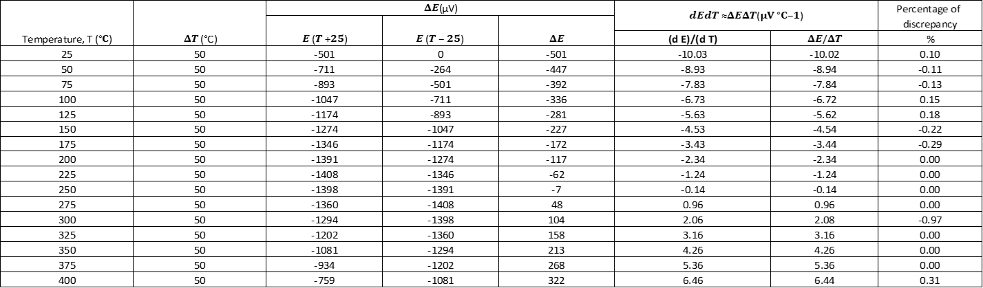

**Appendix 7:**

**Figure 10**: Graph of dE/dT against Temperature (T) of Cu/Fe thermocouple

(*Define the datasets*)

t1 = {{25, -10.03}, {50, -8.93}, {75, -7.83}, {100, -6.73}, {125, \

-5.63}, {150, -4.53}, {175, -3.43}, {200, -2.34}, {225, -1.24}, {250, \

-0.14}, {275, 0.96}, {300, 2.06}, {325, 3.16}, {350, 4.26}, {375,

5.36}, {400, 6.46}};

t1error = {{Around[25, 1], Around[-10.03, 0.01]}, {Around[50, 1],

Around[-8.93, 0.01]}, {Around[75, 1],

Around[-7.83, 0.01]}, {Around[100, 1],

Around[-6.73, 0.01]}, {Around[125, 1],

Around[-5.63, 0.01]}, {Around[150, 1],

Around[-4.53, 0.01]}, {Around[175, 1],

Around[-3.43, 0.01]}, {Around[200, 1],

Around[-2.34, 0.01]}, {Around[225, 1],

Around[-1.24, 0.01]}, {Around[250, 1],

Around[-0.14, 0.01]}, {Around[275, 1],

Around[0.96, 0.01]}, {Around[300, 1],

Around[2.06, 0.01]}, {Around[325, 1],

Around[3.16, 0.01]}, {Around[350, 1],

Around[4.26, 0.01]}, {Around[375, 1],

Around[5.36, 0.01]}, {Around[400, 1], Around[6.46, 0.01]}};

(*Fit linear models to the data*)

fitt1 = LinearModelFit[t1, x, x];

(*Extracting uncertainties in the slope of each fit*)

uncertainty1 = fitt1["ParameterTableEntries"][[2, 2]];

(*Extract equations as strings*)

eq1 = ToString[TraditionalForm[y == fitt1["BestFit"]]];

(*Existing code for plotting*)Column[{combinedPlot =

Show[ListPlot[{t1error}, PlotStyle -> {Red},

PlotLegends -> {"Cu/Fe thermocouple"}],

Plot[{fitt1[x]}, {x, 0, 420}, PlotStyle -> {Red}], Frame -> True,

FrameLabel -> {"Temperature, (°C)",

"dE/dT, \!\(\*SuperscriptBox[\(µV°C\), \(-1\)]\)"},

GridLines -> Automatic,

PlotLabel -> "dE/dT against Temperature (T)", ImageSize -> 500];

(*Displaying the results*)

Column[{combinedPlot,

Row[{"Cu/Fe thermocouple: ", eq1, ", Uncertainty in Slope: ",

uncertainty1}]}]

}

]

**Appendix 8:**



**Appendix 9:**

**Figure 11**: Graph of E/T against Temperature (T) of Cu/Fe thermocouple.

(*Define the datasets*)

t1 = {{25, -10.56}, {50, -10.02}, {75, -9.48}, {100, -8.93}, {125, \

-8.38}, {150, -7.83}, {175, -7.28}, {200, -6.73}, {225, -6.18}, {250, \

-5.63}, {275, -5.08}, {300, -4.53}, {325, -3.98}, {350, -3.43}, {375, \

-2.88}, {400, -2.34}};

t1error = {{Around[25, 1], Around[-10.56, 0.01]}, {Around[50, 1],

Around[-10.02, 0.01]}, {Around[75, 1],

Around[-9.48, 0.01]}, {Around[100, 1],

Around[-8.93, 0.01]}, {Around[125, 1],

Around[-8.38, 0.01]}, {Around[150, 1],

Around[-7.83, 0.01]}, {Around[175, 1],

Around[-7.28, 0.01]}, {Around[200, 1],

Around[-6.73, 0.01]}, {Around[225, 1],

Around[-6.18, 0.01]}, {Around[250, 1],

Around[-5.63, 0.01]}, {Around[275, 1],

Around[-5.08, 0.01]}, {Around[300, 1],

Around[-4.53, 0.01]}, {Around[325, 1],

Around[-3.98, 0.01]}, {Around[350, 1],

Around[-3.43, 0.01]}, {Around[375, 1],

Around[-2.88, 0.01]}, {Around[400, 1], Around[-2.34, 0.01]}};

(*Fit linear models to the data*)

fitt1 = LinearModelFit[t1, x, x];

(*Extracting uncertainties in the slope of each fit*)

uncertainty1 = fitt1["ParameterTableEntries"][[2, 2]];

(*Extract equations as strings*)

eq1 = ToString[TraditionalForm[y == fitt1["BestFit"]]];

(*Existing code for plotting*)Column[{combinedPlot =

Show[ListPlot[{t1error}, PlotStyle -> {Red},

PlotLegends -> {"Cu/Fe thermocouple"}],

Plot[{fitt1[x]}, {x, 0, 420}, PlotStyle -> {Red}], Frame -> True,

FrameLabel -> {"Temperature, (°C)",

"E/T, \!\(\*SuperscriptBox[\(µV°C\), \(-1\)]\)"},

GridLines -> Automatic,

PlotLabel -> "E/T against Temperature (T)", ImageSize -> 500];

(*Displaying the results*)

Column[{combinedPlot,

Row[{"Cu/Fe thermocouple: ", eq1, ", Uncertainty in Slope: ",

uncertainty1}]}]

}

]

**Appendix 10:**







**Appendix 11:**

**Figure 12**: Derivations of the formula used to find the uncertainty of experimental thermal conductivity, k (Written by Latex).

\documentclass[12pt]{article}

\usepackage{geometry}

\geometry{left=1in, right=1in, top=1in, bottom=1in}

\usepackage{amsmath} % For mathematical symbols and equations

\usepackage{ams symb}%For some mathrelationsymbol

\usepackage{siunitx}

\usepackage{mathrsfs} % Include the mathsymbol package

\usepackage{graphicx} % For including figures

\graphicspath{{./figure/}}

\DeclareGraphicsExtensions{.pdf,.jpeg,.png,.jpg}

\usepackage{lipsum} % For generating placeholder text (remove this in your actual document)

\usepackage{tasks}

\begin{document}

\begin{align*}

d_{\text{avg}} &= \frac{d_1 + d_2}{2} \\

\Delta d_{\text{avg}} &= \sqrt{\left(\frac{1}{2} \Delta d_1\right)^2 + \left(\frac{1}{2} \Delta d_2\right)^2} \\

\\

A &= \pi \left(\frac{d_{\text{avg}}}{2}\right)^2 = \frac{\pi}{4} d_{\text{avg}}^2 \\

\left(\frac{\Delta A}{A}\right)^2 &= \left(2 \frac{\Delta d_{\text{avg}}}{d_{\text{avg}}}\right)^2 \\

\Delta A &= A \sqrt{\left(2 \frac{\Delta d_{\text{avg}}}{d_{\text{avg}}}\right)^2} = 2 A \frac{\Delta d_{\text{avg}}}{d_{\text{avg}}} \\

\\

R_a &= \frac{m_a}{t_a} \\

\left(\frac{\Delta R_a}{R_a}\right)^2 &= \left(\frac{\Delta m_a}{m_a}\right)^2 + \left(\frac{\Delta t_a}{t_a}\right)^2 \\

\Delta R_a &= R_a \sqrt{\left(\frac{\Delta m_a}{m_a}\right)^2 + \left(\frac{\Delta t_a}{t_a}\right)^2} \\

\\

R &= \frac{m_w}{t} \\

\left(\frac{\Delta R}{R}\right)^2 &= \left(\frac{\Delta m_w}{m_w}\right)^2 + \left(\frac{\Delta t}{t}\right)^2 \\

\Delta R &= R \sqrt{\left(\frac{\Delta m_w}{m_w}\right)^2 + \left(\frac{\Delta t}{t}\right)^2}\\

\\

R_0 &= R - R_a \\

\Delta R_0 &= \Delta R + \Delta R_a \\

\\

k &= \frac{R_0 h \times 80 \, \text{cal g}^{-1}}{A \Delta T} \\

\left(\frac{\Delta k}{k}\right)^2 &= \left(\frac{\Delta R_0}{R_0}\right)^2 + \left(\frac{\Delta h}{h}\right)^2 + \left(\frac{\Delta A}{A}\right)^2 \\

\Delta k &= k \sqrt{\left(\frac{\Delta R_0}{R_0}\right)^2 + \left(\frac{\Delta h}{h}\right)^2 + \left(\frac{\Delta A}{A}\right)^2}

\end{align*}

\end{document}